# Introduction

**Indigenous businesses provide a significant economic, social and cultural contribution to Australia.** Their impact has largely gone unnoticed, and it has been difficult to realise greater visibility of their achievements. Moreover, rigorous evidence-based measurement of the extent of this contribution has been difficult until now. This is primarily due to the challenging nature of identifying, and analysing, Indigenous businesses from national data sources.

This report provides such data, evidence and analysis. We present an **unprecedented snapshot of the Indigenous business sector that will dismiss the many stereotypes and myths that have led to lost opportunities for Indigenous business growth.** The implication of this blind spot is that decision makers are not armed with either comprehensive or detailed insights into the Indigenous business sector. Consequently, decisions are made based upon examples and knowledge outside the context of the Indigenous business sector.

**Indigenous business development and growth is an essential ingredient needed to fuel financial independence.** Policy and capability development initiatives require objective evidence as a base from which to identify and focus upon areas that need most assistance. Indigenous Australia has been historically excluded from the national economy. In order to dismiss this trope, empirical evidence is required to comprehensively inform policy.

**What we present today is a snapshot that clearly and empirically establishes the economic power of Indigenous businesses.**

This economic power is demonstrated through the financial and employment contributions Indigenous business owners make to the Australian economy. Further, we present powerful validation of growth of the Indigenous business sector over a twelve-year period 2006-2018. The Snapshot Study 1.0 quantifies the performance of the Indigenous business sector, showcasing its breadth, diversity, and impact.

Our partner, the Australian Bureau of Statistics, was successful in linking 6,200 Indigenous businesses from a sample size of 8,368 business ABNs (77%) collected and collated as I-BLADE (Indigenous Business Longitudinal Analysis Data Environment). However, only around 60% were identified by the ABS as being active businesses (tax reporting). Therefore, the results presented in this Snapshot Study 1.0 is based upon the data pertaining to those active businesses (around 3,600 in 2018). A detailed explanation of the sample can be found later in this report.

**Registered Indigenous businesses performance**

|  |  |  |  |
| --- | --- | --- | --- |
| **Indicator** | **FY2006** | **FY2012** | **FY2018** |
| **Number of businesses** | 1841 | 2273 | 3619 |
| **Gross income ($2020)** | $2.27 billion | $3.64 billion | $4.88 billion |
| **Employment** | 22,715 | 31,187 | 45,434 |

Over the 12 years examined (FY2006-FY2018), we observed a 74% increase in the number of businesses operating in the Indigenous business sector, a more than doubling in gross income from the sector (115% growth) and more than 22,000 jobs created (100% growth). Compared to non-Indigenous businesses, registered Indigenous businesses are bigger businesses on average — average gross income of $1.6mill in 2018 (29% above $2mill) and 14 employees, compared to $400K and 2 employees for non-Indigenous businesses.

## A brief history leading to the Snapshot Study Series

In 2018, Dr Michelle Evans, with the research assistance of Sarah Kurland and Lan Hoang, initiated discussions with Indigenous business data custodians across Australia about the importance of bringing together the disparate lists of Indigenous businesses. These efforts ultimately led to a two-year long process of collation of Indigenous business registries into a unified database. Early on, this research endeavour has been supported by Professor Marcia Langton (Melbourne School of Population and Global Health), Dr Matthew Storey (Faculty of Law and Victorian Aboriginal Heritage Council) along with Melbourne Institute researchers, Dr Cain Polidano and Associate Professor Julie Moschion.

The members of the **Indigenous Business Research Group** (i.e., Michelle Evans, Sarah Kurland, Marcia Langton, Julie Moschion, Cain Polidano, and Matt Storey) foresees the significance of an annual Snapshot of the Australian Indigenous Business sector for a number of important reasons. This research will inform the Indigenous business sector ecosystem, including community, government, corporate, banking, education and investment stakeholders. The snapshot will capture an image of the Indigenous Business sector year on year, allowing for deeper insights over time. Lastly (and critically), it will show the impact of focused sector support, such as the introduction of Indigenous preferential procurement programs (hereafter IPPP).

# Acknowledgements

The inaugural Indigenous Business Sector Snapshot Study was made possible by the contributions of a wide range of individuals, partners, Indigenous business data custodians and communities.

An integral part to this research journey was the initiation of a formal partnership with the Australian Bureau of Statistics (ABS) to develop an Indigenous dataset for their Business Longitudinal Analysis Data Environment (BLADE). Together we have made a commitment to the ongoing development of the data and to upholding the Indigenous data sovereignty of the data custodians.

The Indigenous Business Research Group is especially grateful to the support of our research partners National Indigenous Australians Agency, Supply Nation, BP Australia (Ironbark JV), BHP, FMG, Crown Resorts Limited, Minerals Council of Australia, Industry Capability Network Limited, and the Office of Registrar of Indigenous Corporations have supported the development of this research. Our research partners value an empirical evaluation of the Indigenous preferential procurement and its impact on the growth of the Indigenous business sector.

We are appreciative of academic colleagues who have provided generous and expert feedback across the long development period of the data and analysis represented in this report. We wish to publicly thank Professor Paul Jensen, Professor Boyd Hunter, Professor Beth Webster, Professor Alfons Palangkaraya, Professor Dennis Foley, and Dr Victor Sojo.

**This report would not have been possible without the contribution of Indigenous business owners who made a decision to make their enterprise visible by listing it. We thank you for your leadership and contribution to this important initiative.**

## What follows

The Snapshot Study is presented over five sections – (i) establishing I-BLADE, (ii) Breadth, (iii) Diversity, (iv) Impact and (v) Future Developments of I-BLADE. These five sections aim to provide the best empirical overview of the Indigenous business sector available today. Over the coming years, the Indigenous Business Research Group aims to continue collaborating with Indigenous business data custodians and the ABS to collectively develop greater data richness and overcome the limitations of the first wave of I-BLADE.

We look forward to an ongoing dialogue with the Indigenous business sector including stakeholders invested in the development of growth of the sector. Contact us at [cibl.research@unimelb.edu.au](mailto:cibl.research@unimelb.edu.au)

Indigenous Business Longitudinal Analysis Data Environment (I-BLADE)

The objective of I-BLADE is to generate a perpetual longitudinal dataset that tracks all **Indigenous businesses, defined by having at least 50% ownership, including corporations**, over time. This definition of an Indigenous business is consistent with that used by the National Indigenous Australian Agency (NIAA):

*Indigenous enterprise means an organisation, operating a business, that is 50 per cent or more Indigenous owned. It may take the form of a company, incorporated association or trust. A social enterprise or registered charity may also be an Indigenous enterprise if it is operating a business* (NIAA, 2020, p. 4)

We acknowledge that there is debate about the definition of an Indigenous business, as articulated by Foley (2013) who argues that the definition of an Indigenous business should be directly analogous to the legal and governmental definitions of whether a person is accepted as Indigenous. However, as stated by Shirodkar, Hunter and Foley (2018), applying this definition to quantitative datasets is inaccessible due to the qualitative processes required to verify Indigenous identity. In I-BLADE 1.0, we use the 50% ownership criterion, as this is the generally accepted definition across all four business registries.

**This is an ambitious multi-year project that will involve extensive data development and annual data updates through a partnership involving government, data custodians and researchers.** This section describes the construction of I-BLADE 1.0, which is a first step along the path to reaching the objective.

In I-BLADE 1.0, the focus has been on integrating Indigenous business information from four Indigenous business registries, that generally require 50% Indigenous ownership for registration, with Australian Taxation Office (ATO) financial business data known as Business Longitudinal Analysis Data Environment (BLADE) that is compiled and warehoused by the ABS. The core BLADE includes annual financial information from the following ATO sources:

* Business Activity Statements (BAS),
* Business Income Tax (BIT) forms, and
* Pay as You Go (PAYG) wage summaries.

The four business registries incorporated into I-BLADE 1.0 are Supply Nation Registry, Office of Registrar of Indigenous Corporations (ORIC) Database, Industry Capability Network (ICN) Gateway and the Victorian Aboriginal Business Directory (VABD). In this section, we discuss registry and BLADE data and spell out the process undertaken to develop I-BLADE 1.0. For details of the process for integrating Indigenous business registries and BLADE, see the Technical Appendix.

## Indigenous businesses registries

In the main, these registries are held to promote Indigenous businesses through searchable online datasets except in the case of the ORIC Database which is held primarily for governance purposes. Business registration is free and requires at least 50% Indigenous ownership, although ownership information is not always verified equally across these registries. Except for Australian Business Numbers (ABNs), which is vital for integration with BLADE, the information in the registries varies markedly and, as a result, is not of much value to I-BLADE. In future versions of I-BLADE, it is hoped this project will enable co-ordination of registry data collection, especially data on verification of Indigenous ownership, that would allow for deeper insights into the sector. In total, there are 11,409 records (not all unique) in these registries.

To register with **Supply Nation**, businesses are required to provide Confirmation of Aboriginality documents and are required to prove at least 50% Indigenous ownership of the business. Verification is conducted before registration occurs. Supply Nation also conducts annual audits and spot checks to make sure that businesses remain compliant, including continual improvement process check via Australian Securities Investment Commission. Registered businesses that are majority (51% or more) owned, controlled and managed by Indigenous people are eligible for Supply Nation Certification. Data provided by Supply Nation for integration is for existing membership of registered businesses as of 23 June 2020 (2,463 businesses). The data provided by Supply Nation for I-BLADE 1.0 excludes businesses that were previously registered (back to 2013) but are not in the database because they are no longer active or because the business no longer meets the requirement for registration.

**ICN Gateway** data is an online business networking platform established in 2003 that contains a searchable database of more than 80,000 suppliers, with an aim of streamlining project procurement that meets local and Australian industry procurement policy and participation requirements. Indigenous businesses registered in the ICN Gateway can originate from two sources. First, Indigenous businesses can voluntarily register their own profile for free and are asked to identify whether their business is Indigenous owned, and if so, whether the ownership has been verified and the level of ownership (%). Alternatively, Indigenous businesses registered with the Aboriginal Business Directory WA (ABDWA) (Chamber of Commerce and Industry WA) and Black Business Finder (Developed by ICN for the Queensland Government) are automatically included in the ICN Gateway.[1] Both of these registries were launched with state government support in 2012. To be registered in ABDWA, Indigenous businesses must be at least 50% Aboriginal owned and the Aboriginal interests are represented in management and operation of the entity. The ABDWA also includes incorporated Aboriginal Organisations, which requires at least 50% of the controlling board of management be Aboriginal and Aboriginal interests represented in the operation of the entity. Businesses in Black Business Finder must be at least 50% Indigenous owned, a non-Indigenous business with at least 75% Indigenous employees or an equal joint venture agreement with a majority owned Indigenous entity. Indigenous ownership of businesses on Black Business Finder and ABDWA are not always verified. ICN Gateway data provided for integration into I-BLADE 1.0 included all registered Indigenous businesses (2,268) as of 20 August 2020, including businesses that are no longer trading. Future waves of I-BLADE will include identifiers for whether the businesses originate from ABDWA and Black Business Finder.

The **Victorian Aboriginal Business Directory** (VABD) is managed by the Victorian Department of Jobs Precincts and Regions.[2] To register online, the requirement is that the business is at least 50% Indigenous owned, although ownership is not automatically verified. VABD mostly contains businesses that are registered with the Victorian Aboriginal Chamber of Commerce (Kinaway) Directory, which was established in 2018. To be registered on the Kinaway Directory, businesses must provide Aboriginality documents and documents of ownership.[3] Data provided by DJPR were for 331 registered businesses as of 24 July 2020. In future versions of I-BLADE, businesses in VABD that originate from Kinaway will be separately identified from businesses that are registered directly online.

The **ORIC database** contains information on all Indigenous Corporations back to 1979 under the *Corporations (Aboriginal and Torres Strait Islander) Act 2006* (CATSI Act) or its predecessor, the *Aboriginal Councils and Associations Act 1976 (*the ACA Act).[4] However, the ORIC database does not include all Indigenous Corporations. Indigenous Corporations can still be registered under the *Corporations Act 2001*, which is managed by the Australian Securities and Investment Commission, or under state/territory legislation. Indigenous Corporations are commonly not-for-profit or charitable organisations that are established for the benefits of its members that are spelt out in individual corporation rules. Members of corporations have limited liability if the company is wound-up and cannot issue dividends or shares and must re-invest all surplus funds to the company in accordance with the company’s purpose. The data provided for integration into I-BLADE was the complete dataset on 21 May 2020, which contained information for 6,348 corporations. For each company an Indigenous Corporation Numbers (ICNs) was provided, and in some cases, an ABN as well (where they exist). At present only ABN is used for linkage in BLADE. The implications are discussed in later sections.

## Sample of analysis

The final I-BLADE sample for analysis is presented in Table 1. Because in all years of BLADE all ABNs are represented, we observe a consistent match rate in every year. However, when describing the Indigenous business sector in this report, we restrict the analysis to businesses that are alive (their date of birth, from the ABS Registry, falls on or before the given year) and active (registered as active in the ABS Business Registry for tax purposes) in a given year.

In 2018, around 60% of Indigenous businesses that are alive are also active (Table 1), a rate that is comparable to non-Indigenous businesses. Among Indigenous businesses that are inactive in any one year, around a quarter are inactive in all years. These businesses may either be not trading or are trading at a level that is below the thresholds for GST/PAYG wage reporting or may be part of a group of businesses that have centralised ownership (e.g., part of a trustee firm) where reporting on behalf of all business is through a single ABN.

For the remaining three-quarters of inactive businesses, their activity status has changed over time, which may represent changes in the ABN that owners report tax through, changes in trading status or reduced business activity. This is consistent with the notion that activity is a measure of tax reporting, not a measure of business termination — it is not uncommon in the data for inactive businesses in one year to be re-activated in the following year.

**Table 1: Number of alive businesses in I-BLADE**

|  |  |  |  |  |  |  |  |
| --- | --- | --- | --- | --- | --- | --- | --- |
| Year | Numbers of Indigenous businesses that are matched | Numbers of business that are matched, alive and active | Registry of origin for  matched and alive businesses | | | | |
|  |  |  | Multiple registries | ICN | DJPR | SN | ORIC |
| 2006 | 6,236 | 2,178 | 490 | 309 | 20 | 141 | 1,218 |
| 2007 | 6,239 | 2,062 | 453 | 310 | 16 | 128 | 1,155 |
| 2008 | 6,241 | 2,120 | 480 | 364 | 19 | 144 | 1,113 |
| 2009 | 6,238 | 2,165 | 502 | 409 | 26 | 158 | 1,070 |
| 2010 | 6,239 | 2,293 | 534 | 463 | 30 | 176 | 1,090 |
| 2011 | 6,240 | 2,411 | 566 | 520 | 32 | 217 | 1,076 |
| 2012 | 6,240 | 2,526 | 588 | 577 | 31 | 247 | 1,083 |
| 2013 | 6,251 | 2,625 | 622 | 620 | 36 | 261 | 1,086 |
| 2014 | 6,256 | 2,804 | 676 | 685 | 43 | 326 | 1,074 |
| 2015 | 6,254 | 2,949 | 727 | 695 | 47 | 390 | 1,090 |
| 2016 | 6,254 | 3,166 | 821 | 694 | 55 | 486 | 1,110 |
| 2017 | 6,261 | 3,351 | 914 | 683 | 65 | 580 | 1,109 |
| 2018 | 6,256 | 3,619 | 995 | 675 | 74 | 728 | 1,147 |
| Total | 81,205 | 34,269 | 8,368 | 7,004 | 494 | 3,982 | 14,421 |

Note: there were 8,133 unique businesses in the Indigenous business registries (Supply Nation registry, ICN Gateway data, Victorian Aboriginal Business Directory or the ORIC database). Active businesses are those that appear as active on the ABS Business Registry for tax filing purposes. We exclude those that are non-active.

We restrict the analysis from 2005-06 although the data is available from 2001-02 because it provides us with at least 5 years of data to be able to measure date of birth for all businesses. Around a quarter of all businesses in BLADE have a notional birth date of 2000-01, which is because the BAS data, which is used to identify birth date, was not collected prior. Over the period 2006-18, the number of alive and active businesses varies from 2,178 to 3,619.

In this report, we analyse a range of business outcomes, the key ones being gross business income, employment numbers, wage cost and average annual wage rate per full-time equivalent. These are chosen mainly because they are items of interest that are available across all business types. Sole traders, registered companies, trusts and partnerships all have different taxation reporting requirements. The PAYG employment data only includes records for a subset of businesses that have employees. When generating measures of business employment, we treat missing records in the PAYG data as ‘no employees’, but only if the business also records a BIT or BAS (vast majority of cases). We exclude cases where there is no BIT or BAS data because the missing PAYG data may reflect missing data (e.g., late tax filing) and not a lack of employees.

For continuous measures of employment and gross income numbers (including averages and total, but not categorical variables, e.g., proportion of businesses that employ more than 200 people), we exclude the top 2% of Indigenous and non-Indigenous businesses. In both sectors, we observe a handful of very large businesses that have undue influence on sector averages and totals, including businesses that have very large year-on-year changes. In practice, whether such large year-on-year changes are real or due to mergers or acquisitions is unclear. Working with ABS partners, we hope to develop measures to better identify mergers/acquisitions in future waves of I-BLADE.

## Limitations of the analysis

Consistent with the preliminary nature of I-BLADE 1.0, there are important caveats to keep in mind when interpreting the results presented in this report. These caveats relate to the Indigenous business data collection, the Integration of the data into I-BLADE and BLADE itself, which represent items for future data development with ABS partners and business registry data custodians.

### Business registries

While the goal is to extend I-BLADE to include all Indigenous business that appear on registries, currently we are limited to business from only four registries, and we cannot be sure how representative these are of all business on Indigenous registries. Issues of registry coverage aside, the bigger issue is whether Indigenous business registries are representative of all businesses with at least 50% Indigenous ownership. In practice, businesses selection, either self-selected or selected by procures, for registration is likely to be related to the benefits and costs of doing so.

As discussed above, business registries include patchy and inconsistently measured business data that, while not core to the registries themselves, can provide important contextual information for I-BLADE that can help support research. Perhaps most important is consistent historical registry information. While the registries themselves commenced at different times, some of the registry data provided only contains current registry members, not past member information. An implication is that any apparent growth in the sector may be exaggerated by more limited coverage as you go back in time. To demonstrate the impact of this, in Table 1 we can see contrasting business numbers over time between ORIC, whose registry includes businesses back to 1979, and Supply Nation, whose supplied business registry only includes currently registered businesses. In contrast to the ORIC numbers, the numbers of linked Supply Nation businesses diminish rapidly in historical years. In future versions of I-BLADE, we hope to extend coverage of historical data for existing and new registries and incorporate, where possible, dates for entering and exiting the registries, reflecting changes in business ownership.

### BLADE

Because BLADE comprises linked administrative data, its underlying data is for administrative (tax) purposes and not for research, which means that the data is often constrained by administrative rules. For example, business activity is only available for ABNs through which financial information is reported. Because of centralised reporting, that financial data may be aggregated over other commonly owned businesses. As is commonly the case, it is possible to get around these limitations through the addition of other administrative sources (e.g., by the inclusion of ownership information to link businesses together), but this takes time. As a research tool, BLADE is still in its infancy, with data only recently made available outside of government.

As discussed above, we exclude businesses that are inactive based on their tax filing status, which may distort business average measures. Some of these ‘tax inactive’ businesses may be active in practice because they are part of a cluster of businesses held by the same owner who centralises tax through one ABN. To the extent that this is true, then business average statistics will be over-inflated to a degree. While we need to express caution in interpreting the business average results, from the data available, there is nothing that suggests that this problem may have changed over time or differently affects Indigenous and non-Indigenous businesses.

# Breadth of the Indigenous Business Sector

**The integration of Indigenous businesses from four registries with BLADE to create I-BLADE 1.0 provides the best glimpses of the sector that is at least 50% Indigenous owned.** Other studies have focussed on examining the nature of businesses from one registry, Supply Nation (Supply Nation 2020) or on owner-managers (not businesses) who self-identify as Indigenous from the Census (Shirodkar et al., 2018).

**In 2017-18, the last year in I-BLADE 1.0, we observe 3,619 active businesses, employing 45,434 people generating total gross income of $4.9bill (2020 terms).** To put this into perspective, this is around the same as the value of Australia’s production of vegetable crop and more than cotton crop $2.5bill in 2017-18 (ABS 2019). It is important to keep in mind that this is likely to be an under-estimate of the true size of the sector, defined by whether a business is 50% Indigenous owned and registered. As discussed in a previous section, not all unique Indigenous businesses (8,133) identified in the current four registries could be linked to BLADE. As a result, I-BLADE 1.0 does not include information from all registries and there are likely to be other businesses that are at least 50% Indigenous that are not registered because they may not benefit from registering or be discriminated against if they do (Foley, 2000).

In understanding the breadth of the sector, **we address three key questions: (i) what is the size and nature of Indigenous businesses in I-BLADE, (ii) how has the sector, as represented by these registered businesses in I-BLADE, grown and (iii) where are Indigenous businesses located?**

## What is the size and nature of Indigenous businesses in I-BLADE?

The incomplete coverage of Indigenous businesses in I-BLADE 1.0 raises the question of who are the businesses that are currently captured in the data, and do they represent all Indigenous businesses with at least 50% ownership? In the absence of a population benchmark, we examine the nature of Indigenous businesses compared to those of the non-Indigenous sector below.

Based on comparison with non-Indigenous businesses, we conclude that Indigenous businesses in I-BLADE 1.0 are much larger on average than non-Indigenous businesses. Compared to non-Indigenous businesses, **Indigenous businesses in I-BLADE:**

* **are less likely to be sole traders**. On average only 9% of Indigenous businesses in I-BLADE are sole traders, which compares to 32% for non-Indigenous businesses (Figure 1). For Indigenous businesses in I-BLADE, the majority are registered companies, 72%.

**Figure 1: Types of businesses, 2017-18**

Source: I-BLADE 1.0, restricted to businesses that are active for tax purposes. Indigenous businesses are from Indigenous business registries (Supply Nation registry, ICN Gateway data, Victorian Aboriginal Business Directory or the ORIC database).

Note: Categories of business type are based on business registration status in the ABS Business Registry.

* **are less likely to be categorised as small businesses, based on the ABS definition of employing less than 20 people (ABS 2001).** 81% of Indigenous businesses in I-BLADE employ less than 20 people, compared to 96% of non-Indigenous businesses (Figure 2).[5] On average, Indigenous businesses in I-BLADE employ 14 people compared to non-Indigenous businesses which employ 2 people on average.

**Figure 2: Employment profile of Indigenous and non-Indigenous businesses, 2017-18**

Source: I-BLADE 1.0, restricted to businesses that are active for tax purposes. Indigenous businesses are from Indigenous business registries (Supply Nation registry, ICN Gateway data, Victorian Aboriginal Business Directory or the ORIC database).

* **generate gross income that is 4 times that of non-Indigenous businesses in BLADE.** On average, Indigenous businesses in I-BLADE have a gross annual income of $1.6mill., compared to $400K for non-Indigenous businesses. Across ABS remoteness areas, the average Indigenous business gross income is greatest in remote areas $2.1m (4.2 times as large as non-Indigenous businesses on average). This may reflect the importance of the mining and tourism industries to remote Indigenous business income (Figure 3).

**Figure 3: Average business gross income ($2020mill), 2017-18**

Source: I-BLADE 1.0, restricted to businesses that are active for tax purposes. Indigenous businesses are from Indigenous business registries (Supply Nation registry, ICN Gateway data, Victorian Aboriginal Business Directory or the ORIC database).

Note: Top 2% of Indigenous and non-Indigenous businesses are excluded.

## Growth

A feature of I-BLADE is the integration of historical information, including information on Indigenous businesses that are no longer on registries for all but the Supply Nation registry which accounts for 1 in 5 businesses included in I-BLADE 1.0. This gives a sense of how the sector has evolved over time and indicates factors that may have shaped its growth now and into the future.

Key statistics presented in Figure 4 suggest that **the numbers of active Indigenous businesses have grown at roughly a constant rate of around 4.3% per year from 2005-06 to 2017-18 or from 2,718 in 3,619 overall.** This rate of increase is broadly consistent with the increase in Indigenous owner managers reported by Shirodkar et al. (2018) between 2006 and 2016 (5.5% per year). The rate of growth of employment numbers and total Indigenous business gross income has been higher than for active businesses numbers (5.9% and 6.6% per year), which points to growth in the average size of active businesses, which may point to **a maturing of the sector.**

**Figure 4: Total growth in Indigenous businesses, 2017-18**

Source: I-BLADE 1.0, restricted to businesses that are active for tax purposes. Indigenous businesses are from Indigenous business registries (Supply Nation registry, ICN Gateway data, Victorian Aboriginal Business Directory or the ORIC database).

Unlike growth in business numbers, changes in gross income and employment over time have not followed a linear trajectory, but instead appear to have had their growth interrupted from 2014 by a reduction in mining construction expenditure that had flow-on effects throughout Indigenous businesses. Effects are felt most strongly, but not limited to, Indigenous businesses working in the construction sector, where the growth in gross income over time has broadly followed mining construction expenditure (Figure 5). Perhaps reflecting a willingness of Indigenous employers to retain their staff, the reduction in employment appears to trail the downturn in gross income but recovers quickly once growth in income resumes. These statistics underline the importance of mining sector in supporting Indigenous business growth over the last 12 years.

**Figure 5: Gross income from Indigenous-owned construction (I-BLADE) and value of mining expenditure on construction (ABS)**

Sources: I-BLADE 1.0 (restricted to business that are active for tax purposes and are from Indigenous business registries (Supply Nation registry, ICN Gateway data, Victorian Aboriginal Business Directory or the ORIC database)) and ABS Australian Bureau of Statistics, Private New Capital Expenditure and Expected Expenditure, Australia December 2020.

## Where are Indigenous businesses?

Data on the distribution of Indigenous businesses geographically is vital to understand how the new economic opportunities afforded Indigenous people from the sector’s growth are being shared. Reflecting the value of Indigenous businesses to regional and remote communities, we estimate that **58% of Indigenous businesses in I-BLADE are located outside of major cities — 32% are regional and 26% in remote locations. This compares with the non-Indigenous sector where most businesses are in major cities (74%).**

Interestingly, according to I-BLADE, **Indigenous businesses in remote areas ‘punch above their weight’.** Despite only comprising 26% of all Indigenous businesses, they make-up 34% of total gross income and 37% of all employment for the sector (14,030 jobs in total). This is consistent with the conclusion above that Indigenous businesses are larger on average in remote areas.

In terms of numbers across ABS Statistical Local Areas Level 4 (Figure 6), which are designed to reflect distinct labour markets within states and territories, **the greatest concentration of Indigenous businesses is in outback Western Australia (northern half of WA) and outback Northern Territory, both with more than 200 businesses in 2017-18, mainly in the sectors of construction; business administration; professional, scientific, and technical services.** Other areas of concentration that have **more than 100 businesses in 2017-18 include Cairns, outback (western) Queensland and Darwin**. Despite remote areas having the highest concentration of Indigenous business numbers, in terms of increase in businesses numbers this has been highest in major cities— 8% growth per year on average compared to 2% in remote and 3.7% in regional areas.

It is important to stress that in I-BLADE 1.0, business location is based on business postal address and this cannot be mistaken for the area where the business mostly operates. To the extent that some businesses that operate outside of major cities may have metropolitan head office addresses, then this would under-estimate the true importance of Indigenous businesses to regional and remote areas.

**Figure 6: Number of Indigenous businesses by ABS Statistical Local Areas 4, 2006; 2009; 2012; 2015; 2018**



Source: I-BLADE 1.0, restricted to businesses that are active for tax purposes. Indigenous businesses are from Indigenous business registries (Supply Nation registry, ICN Gateway data, Victorian Aboriginal Business Directory or the ORIC database).

# Diversity of the Indigenous Business Sector

The diversity of Indigenous businesses is an indication of the resilience of the sector in being able to weather economic crosswinds, such as exchange rate fluctuations and commodity price falls, a gauge of the breadth of skills and professional networks of Indigenous entrepreneurs as well as a measure of the range of services that it provides Indigenous people, especially in remote communities.

To measure diversity, we generate a dissimilarity index that measures how different the sectoral composition of Indigenous businesses sector in I-BLADE is from the composition of all other businesses in major cities, regional areas, remote areas and overall.[6] These indices of dissimilarity range from 0 to 1, where 0 represents an Indigenous sectoral composition that exactly matches the composition of the rest of the businesses sector, while at the other extreme a measure of 1 represents sectoral composition that is highly concentrated and dissimilar to the rest of the businesses sector.

The Indices of dissimilarity presented in Figure 7 suggest that in rural and remote areas, the composition of Indigenous businesses sector was quite different to that of non-Indigenous businesses in 2006. However, since 2006 these indices have fallen sharply suggesting that Indigenous business growth in these areas have been associated with sectoral diversification.

**Figure 7: Index of Indigenous businesses sectoral concentration relative to all other businesses**

Source: I-BLADE 1.0, restricted to businesses that are active for tax purposes. Indigenous businesses are from Indigenous business registries (Supply Nation registry, ICN Gateway data, Victorian Aboriginal Business Directory or the ORIC database).

Note: The dissimilarity Index measures how different the sectoral composition of Indigenous businesses are from non-Indigenous businesses. The index varies between 0 and 1, where 0 means that the sectoral composition of Indigenous businesses is exactly the same as Indigenous businesses and 1 is that they are completely different.

In major cities where the numbers of businesses have grown the most, we have observed a slight increase in the dissimilarity index, suggesting that growth in numbers has tended to be mostly concentrated in existing sectors. By 2017-18, we see no difference in the dissimilarity index of Indigenous businesses in major cities and in remote areas. The interpretation is that **Indigenous businesses in remote and major cities are taking up the regional economic opportunities at about the same rate, but that businesses in regional areas are lagging.** A major difference in the sectoral composition of Indigenous businesses and non-Indigenous businesses in regional areas is in the importance of primary industries. **In regional areas, 21% of non-Indigenous businesses are in Agriculture, Forestry and Fishing, compared to only 4% of Indigenous businesses. This underlines the importance of land ownership to business opportunities in regional areas. It also raises important questions about the productive quality of the land Indigenous interests are able to secure via Native Title.**

**Figure 8: Composition of Indigenous businesses by ABS ANZSIC Divisions, 2017-18**

Source: I-BLADE 1.0, restricted to businesses that are active for tax purposes. Indigenous businesses are from Indigenous business registries (Supply Nation registry, ICN Gateway data, Victorian Aboriginal Business Directory or the ORIC database).

Although there are Indigenous businesses represented in all nineteen ABS ANZSIC sectoral divisions in I-BLADE, there are 6 main sectors that comprise over half of all businesses in 2017-18, these are:

* Construction 17%;
* Professional, Scientific and Technical Services 14%;
* Health Care and Social Assistance 10%;
* Administrative and Support Services 7%;
* Rental, Hiring and Real Estate Services 5%; and
* Education and Training 5%.

Reflecting differences in the relative size of businesses and their labour intensity, the contribution of these sectors to employment and gross earnings are quite different (Figure 8). **Health Care and Social Assistance, despite only making up 10% of all businesses, are responsible for 24% of all employees and 19% of gross income. Construction that makes up 17% of all businesses, contributes 12% of all employment and 20% of gross income.**

Over the period of analysis (Figure 9), the contribution of Construction and Professional, Scientific and Technical Services and Administrative and Support Services have grown as a share of all Indigenous businesses in I-BLADE on the back of strong average annual growth in numbers — 8%, 8.5% and 8.6% respectively. On the other hand, the contribution of Health Care and Social Assistance businesses has shrunk. Since 2006, the number of businesses in this sector has remained constant in remote and major cities but has declined slightly in regional areas. The composition of Education and Training and Rental, Hiring and Real Estate Services has remained steady, as their average annual growth rates have remained about the sector average in I-BLADE.

**Figure 9: Composition of Indigenous businesses numbers over time by ABS ANZSIC Divisions**

Source: I-BLADE 1.0, restricted to businesses that are active for tax purposes. Indigenous businesses are from Indigenous business registries (Supply Nation registry, ICN Gateway data, Victorian Aboriginal Business Directory or the ORIC database).

Note: The number of Indigenous businesses in the figure is 3,460 and not 3,619 because 159 Indigenous businesses have missing sectoral data.

Figure 6 shows that Indigenous businesses in I-BLADE are found throughout Australia, but at the ABS SA4 region level, with at least 10 businesses, these sectors are concentrated in remote areas of Australia, especially in outback Northern Territory, Western Australia and Queensland (Figure 10). This is consistent with businesses servicing mining, tourism and health sectors in these areas. In contrast, in regional and major cities, Indigenous businesses operate across more diverse sectors and are geographically more dispersed across ABS SA4 regions so that only one SA4 area in a major city (Darwin) and a handful of SA4s in regional areas have as least 10 businesses in the ‘big six’ sectors. Figure 10 also highlights the extensive nature of Health Care and Social Assistance sector that provide health services throughout remote Indigenous communities.

**Figure 10: Number of Indigenous businesses by key ABS Sector Division, 2017-18**

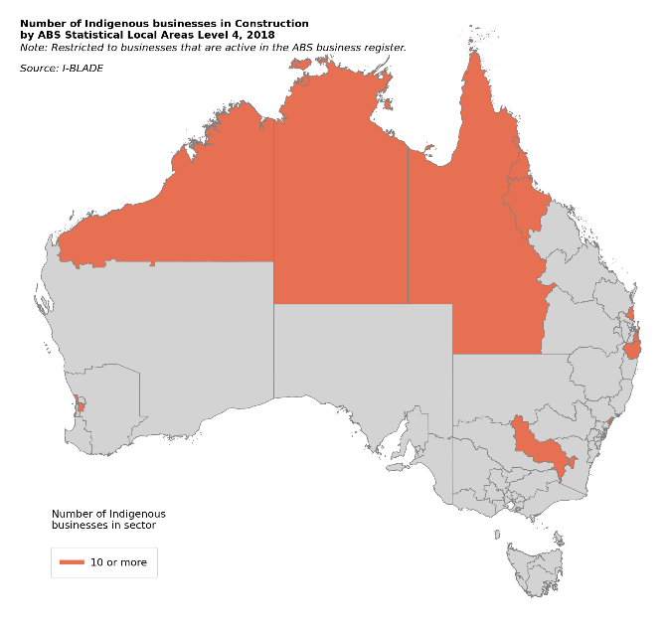 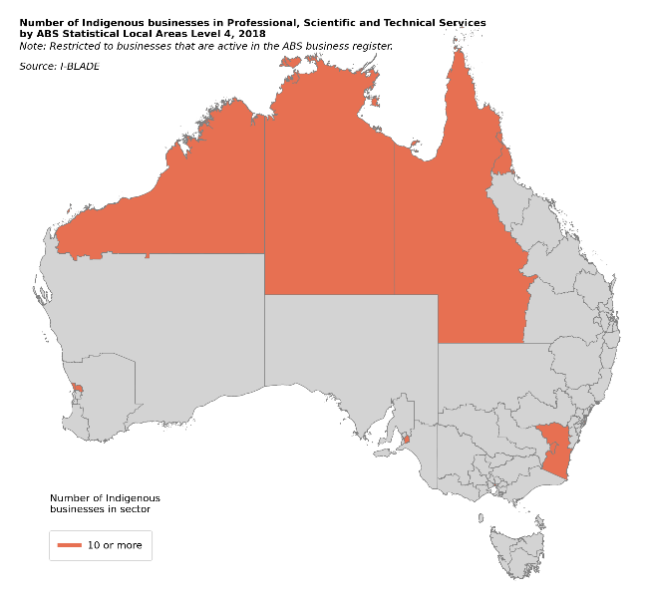

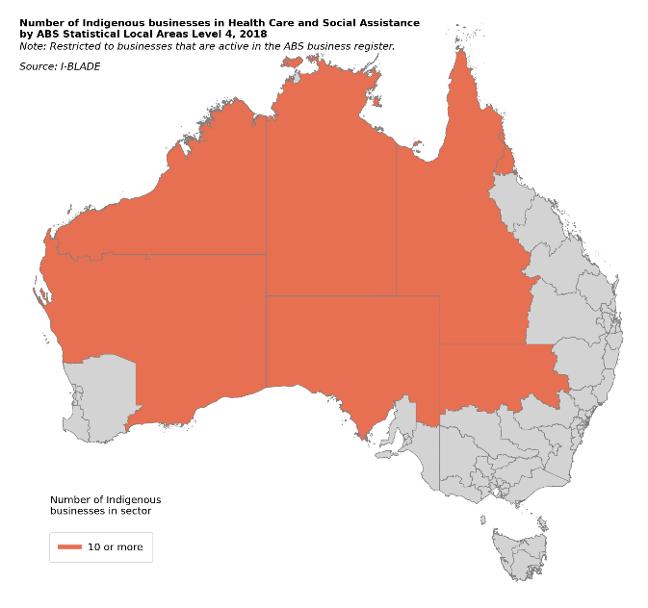 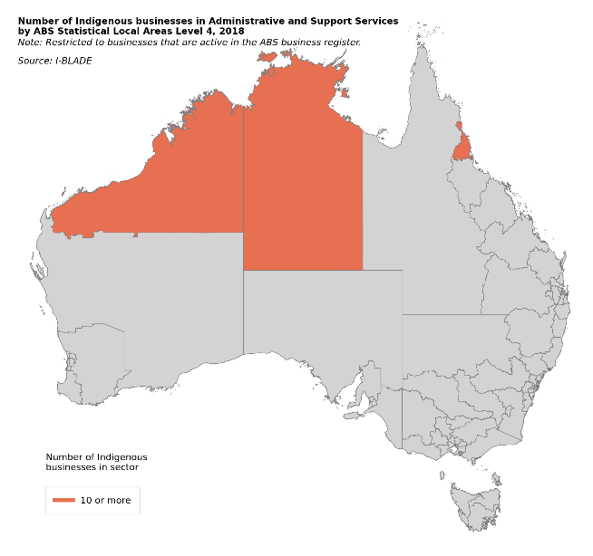

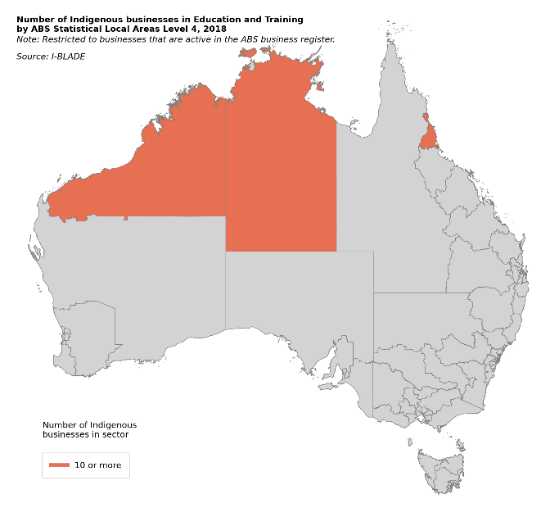 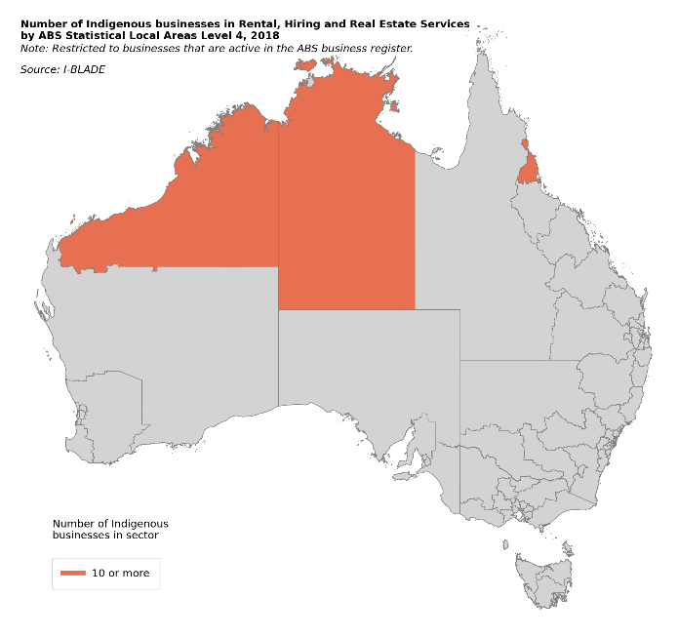

Source: I-BLADE 1.0, restricted to businesses that are active for tax purposes. Indigenous businesses are from Indigenous business registries (Supply Nation registry, ICN Gateway data, Victorian Aboriginal Business Directory or the ORIC database).

# Impact of the Indigenous business sector

**Promoting the growth of the Indigenous business sector is part of a shift in government and corporate policy towards encouraging greater Indigenous entrepreneurship and economic participation.** To these ends, statistics presented above demonstrate that these changes are being realised in Indigenous businesses growth and diversification. While these changes are benefiting Indigenous business owners through improved networks, business skills and financial wellbeing, these are likely to be dwarfed when considered against the wider public benefits to local communities and to all Australians.

These public benefits, often called externalities or spillovers, are incidental benefits of a growing Indigenous business sector and are over and above those that would occur if the same growth were experienced in the non-Indigenous business sector. Ultimately, it is these incidental benefits that motivate government and the corporate sector to support growth in the Indigenous business sector and it is important to articulate, and where possible, quantify them to justify ongoing support for the sector. These benefits take on many forms. First, and most directly, **Indigenous businesses deliver a range of services to local Indigenous communities, including health and education services in a culturally sensitive manner that is essential for ensuring trust and accessibility of service for Indigenous people that rely on them. The services provided by Indigenous businesses are significant, especially in regional and remote areas that are under-serviced.** And further, this business activity attracts associated infrastructure such as air strips, maintained roads and telecommunications.

**The leading role of Indigenous health services in informing and leading the response to COVID-19 in remote communities, where no loss of life was recorded, is testament to the importance of the services that Indigenous businesses provide to their communities** (Crooks et al. 2020). The Indigenous health sector leaders, doctors, professionals and workforce rapidly implemented best practice pandemic planning across all their community-controlled health and welfare organisations. They were well organised and had built collaborations with relevant government departments based on trust. This was one of the best responses of any Indigenous group in the world, saving hundreds of cases and deaths that were expected given the predicted impact of the virus, and also avoiding significant hospital and intensive care costs. Indigenous businesses also provide cultural services to the wider community, for example through art and tourism, that help preserve and educate the wider community about the world’s oldest living culture, enriching the lives of all Australians and building understanding, trust, and social cohesion.

**Indigenous businesses also provide public benefits through employing Indigenous people.** Evidence suggests that Indigenous businesses are more likely than non-Indigenous businesses to hire Indigenous workers (Hunter 2014), which helps overcome discrimination, a major barrier to employment for Indigenous people (Shirodkar 2019, Biddle 2013). **Increased Indigenous employment accelerates income levels and wealth generation, unlikely to occur without employment in an historically dispossessed and excluded population, and catapults individuals out of the welfare economy.** Indigenous businesses may also provide a more culturally supportive working environment that may help in attaining sustainable and rewarding employment for Indigenous employees. To the extent that improved employment rates increase the financial autonomy, self-esteem, and wellbeing of Indigenous people, then this is likely to benefit the wider community through reduced public cost of health and income support payments.

More generally, improved employment and economic opportunities for Indigenous people, can also have transformative impacts on career and life aspirations. There is strong evidence that affirmative action policies that aim to enhance economic opportunities have large impacts on lifting engagement in education and training, an important indicator of future skills and labour market participation (see Holzer and Neumark 2006 for a review). Especially in communities with strong businesses leaders who share their knowledge and networks, the new opportunities can transform the aspirations of an entire community.

Development of a vibrant business sector where Indigenous people participate and interact on equal term with non-Indigenous Australians also can also help build understanding and trust that is vital for healing the nation. This is consistent with the notion that greater connectedness and interactions between people from dominant and minority cultures helps build social capital, a commonly articulated motivations for affirmative action policies (Holzer and Neumark 2006).

## Measuring impact

The public benefits described above are difficult but not impossible to measure. In practice, we can observe community level changes in measures that approximate or ‘proxy’ for a range of social and economic outcomes that coincide with growth in the Indigenous business sector across regions. Such changes are indicative of the impacts of Indigenous businesses, but not necessarily causal impacts — there may be confounding factors that drive both outcomes simultaneously, such as local economic trends. Ideally, we would estimate regional outcomes in the absence of Indigenous business growth, known as counterfactual outcomes as a benchmark, to isolate the effect of Indigenous business growth on community outcomes from the influence of other confounding factors. In I-BLADE 1.0, we have limited measures on community outcomes described above or data to construct counterfactuals to isolate possible causal impacts. This is for future research.

In I-BLADE 1.0, we start from the premise that the public benefits from Indigenous businesses, as described above, are likely to be related to the share of overall employment in the region and the associated pay, the latter being a proxy for the economic returns to the community from a job with an Indigenous business. Data in Figure 11 shows Indigenous business employment numbers as a share of overall ABS SA4 business employment over time. One key observation is that in terms of local employment opportunities, **Indigenous businesses in I-BLADE are consistently most important in remote areas, where Indigenous business jobs comprise more than 2% of all jobs.** Although the employment share in regional areas and major cities is lower, its importance is growing rapidly. In 2006, Indigenous business employment as a share of total business employment only exceeded 1% in 7 ABS SA4 areas in major cities or regional areas, compared to 19 in 2018.

**Figure 11: Employment in Indigenous businesses as a share of all business employment by ABS Statistical Area Level 4, 2006; 2009; 2012; 2015; 2018**



Source: I-BLADE 1.0, restricted to businesses that are active for tax purposes. Indigenous businesses are from Indigenous business registries (Supply Nation registry, ICN Gateway data, Victorian Aboriginal Business Directory or the ORIC database). Excludes employees for the top 2% of Indigenous and non-Indigenous employers.

An interesting result is that jobs with **Indigenous employers in I-BLADE 1.0 pay 3.2% more than jobs with non-Indigenous employers, including in major cities (2.7% higher), regional areas (10% higher) and remote areas (16% higher) (Figure 11).** This may be a result of a few different factors. First, Indigenous businesses in I-BLADE 1.0 are larger than non-Indigenous businesses, which means that they may face less competition for their services/products and be better able to pay higher wages to attract staff. Alternatively, it may represent differences in the skill set of Indigenous and non-Indigenous employees. Compared to non-Indigenous businesses, Indigenous businesses are more concentrated in sectors that deliver professional services (62% relative to 55%) that tend to command higher wages.[7]

**Figure 11: Average annual wage paid to business employees, 2017-18**

Source: I-BLADE 1.0, restricted to businesses that are active for tax purposes. Indigenous businesses are from Indigenous business registries (Supply Nation registry, ICN Gateway data, Victorian Aboriginal Business Directory or the ORIC database). Note: excludes the top 2% of Indigenous and non-Indigenous values.

# Future Developments of I-BLADE

These new findings underline the value of I-BLADE and the importance of further developing the data to better understand the drivers of Indigenous business growth, especially the role played by government and corporate initiatives, and quantifying the flow-on social and economic benefits to the public. **An important future development is working with data custodians, to expand the coverage of registries in I-BLADE and to develop and implement initiatives to grow the coverage of Indigenous owned business on these registries.** This study has shown that Indigenous businesses on these registries are large, much larger than non-Indigenous businesses on average, which may be because they self-select, or are selected by procurers, onto the registries to take advantage of IPPP, a key use of these registries. For small businesses that may not have the capacity to compete for IPPP contracts, the potential cost of time and effort to certify owner’s Indigenous status may not be worth the effort (there is no fee for registration).

While only Supply Nation verify the Indigenous status of all businesses as a condition of registration, the personal and business risk in the event of an audit may also be enough to deter some businesses owners from registering. **The implication is that while the coverage of businesses in I-BLADE may not be representative of the entire sector (that is at least 50% Indigenous owned), it may reflect businesses that stand to benefit from IPPP.** We are currently working with a range of other Indigenous business data custodians that are responsible for maintaining Indigenous business registries in their states/territories, as well as with Indigenous Business Australia (IBA) and South Australian Industry Advocate[8], to ensure that future releases of I-BLADE will have a more comprehensive coverage. However, incorporating all Indigenous business registries into I-BLADE may only go so far, more work is also needed to extend the coverage of Indigenous businesses on registries.

One option is to approach businesses with an online presence that Identify as Indigenous to have their ownership verified with automatic (centralised) business registration across all relevant registries to maximise their business exposure. Such an approach may be accompanied with information about the opportunities afforded under IPPP and the importance of verification. Expanding the coverage of I-BLADE will help to paint a more representative picture of the Indigenous business sector and allow for a better understanding of which Indigenous businesses take advantage of IPPP, which do not, and why not.

Another focus for improving Indigenous registry data is synchronising the collection of business statistics such as sector, business age, industry, Indigenous verification status and location that can be used to verify how different businesses that are linked to BLADE are from businesses that cannot be linked. At present, only 77% of business registries can be linked to BLADE and because the data collected varies markedly across registries, it is difficult to assess how different businesses that can be matched are to those that cannot. Understanding how different unmatched businesses are to matched businesses is important to understand whether the exclusion of unmatched businesses is biasing the sample of analysis. As well as helping to understand the implications of unmatched businesses, the data can also help support analysis, for example, to understand the types of businesses that elect to be verified and help to improve the match rate of Indigenous business to BLADE.

In the future it is possible that such data, which is also common to BLADE, could be used to link businesses where ABN alone is insufficient. Better data from custodians, can also help inform I-BLADE, for example, by helping to identify the location of main businesses activity, which at present is based on head office postcode. Also, at present not all registries have supplied historical data, including businesses that no longer appear in registries, but information about these businesses and when they were on the registries is vital to be able to properly capture the evolution of the sector over time.

As well as working with data custodians, a priority of the I-BLADE development project is to work with the ABS to help develop BLADE. A key priority is improving the understanding of why 40% of Indigenous businesses on registries are apparently inactive for tax purposes. Working with the ABS, we hope to try and identify reasons for inactivity, including identifying businesses that are attached to the same (anonymised) owner that may be inactive because of centralised reporting. Shedding light on the reasons for inactivity is important for measuring business termination/survival, a key performance measure for the sector that we hope to capture in future waves of I-BLADE. Also, better identification of business ownership is vital to identify whether any growth in the Indigenous business sector, especially associated with IPPP, is related to real ‘within business’ growth and not changes in activities associated with Indigenous ABNs, for example, mergers/acquisitions or changes in reporting associated with Indigenous ABNs.

Finally, future versions of I-BLADE will also integrate government and corporate procurement data and employee and Indigenous community wellbeing data for the purpose of measuring impacts of IPPP and the flow-on public benefits to community and the rest of Australia. Integrated data to capture public benefits will include, but will not be limited to, anonymised business employee and community-level data from the Multi-agency Data Integration Project (MADIP) over time. This will enable us to measure impacts on Indigenous employees and overall impacts on Indigenous communities on measures such as financial wellbeing, employment rates, participation in education and training and health expenditure. These developments will help support research into the design and impacts of IPPP and the public benefits that flow to communities and to Australia as a whole.

# References

# ABS 2001, Small Businesses in Australia 2001, cat. no. 1321.0, ABS, Canberra Australia.

Australian Small Business and Family Enterprise Ombudsman (2019). Small Business Counts, Australian Government, Canberra.

Australian Bureau of Statistics (2019). Value of Agricultural Commodities Produced, Australia, ABS cat. no. 7503.0, Canberra.

Biddle, N., Howlett, M., Hunter, B. and Paradies, Y., (2013). Labour market and other discrimination facing Indigenous Australian. *Australian Journal of Labour Economics*, 16(1), pp.91-113.

Crooks, K., Casey, D. and Ward, J. (2020). First Nations peoples leading the way in COVID-19 pandemic planning, response and management Engaging First Nations peoples in public health emergencies is critical to reducing health inequities, *Medical Journal of Australia* 213(4), p. 151-152.

Foley D (2000). Successful Indigenous Australian entrepreneurs: a case study analysis, Aboriginal and Torres Strait Islander Studies Unit Research Report Series, vol 4, University of Queensland, Brisbane.

Foley, D. (2013). Jus sanguinis: the root of contention in determining what is an Australian Aboriginal business. Indigenous Law Bulletin 8(8):25–29.

Holzer, H. and Neumark, D. (2006). Affirmative action: What do we know*? Journal of Policy Analysis and Management* 25(2) pp. 463-490.

Hunter, B. (2014). Indigenous employment and businesses: Whose business is it to employ Indigenous workers? Centre for Aboriginal Economic Policy Research (CAEPR) working paper 95/2014, Australian National University, Canberra.

Shirodkar, S., Hunter, B. Foley, D. (2018). Ongoing growth I the number of Indigenous Australian Businesses, Centre for Aboriginal Economic Policy Research (CAEPR) working paper 125/2018, Australian National University, Canberra.

Shirodkar, S., 2019. Bias against Indigenous Australians: Implicit association test results for Australia. *Journal of Australian Indigenous Issues*, 22(3-4), pp.3-34.

National Indigenous Australians Agency (NIAA) 2020, Indigenous Procurement Policy, NIAA, <https://www.niaa.gov.au/sites/default/files/publications/ipp-guide.pdf> (accessed 3 April 2020).

Supply Nation (2020). State of Indigenous businesses, driving growth across the Indigenous business sector, Supply Nation Research Report 1, <https://supplynation.org.au/research-paper/state-of-indigenous-business-driving-growth/> (accessed 3-4-2021).

# Technical appendix

## Indigenous business registry data integration with BLADE

To link Indigenous business registry data to BLADE is through a ‘linkage key’ that maps unique ABNs in the Indigenous business registry to anonymised business identifiers in BLADE. Before the Indigenous business data is linked to BLADE, the registry data is cleaned to maximise the likelihood of the data being successfully linked with BLADE. We first remove duplicates with the same name (that appear in more than one database and also sometimes multiple times in the same registry). We rely on business name to remove duplicates (not ABN) because in many cases (3,940 out of 11,409 registry records) were missing a valid ABN, either because no ABN was provided (including, but not limited to, corporations in ORIC) or because the ABN provided was not an 11-digit number. To identify businesses that have a unique name, we first standardise the formatting of the business names.[9]

Because ABS linkage of Indigenous business data to BLADE is based on a unique common ABN, it is vital that the Indigenous business ABNs are correct and up-to-date.[10] For this reason, we enter all cleaned business names into the ABN Lookup tool on the Australian Business Register website (<https://abr.business.gov.au/Tools/AbnLookup>) and retrieve all ABNs that are associated with the business name that have a name character match of at least 98%, which based on our testing, is a conservative measure for a reliable ABN match. In some cases, more than one match is retrieved. In these cases, the highest match is the preferred ABN, but the alternative ABNs are retained for the data integration with BLADE in case the preferred match is not successful. In practice businesses may have multiple ABNs if the business acts as a trustee for other businesses. It is also important to note that ABNs are not unique to a business. As long as they are the same structure (e.g. company, sole trader), an owner can register multiple companies under the one ABN, for example, for ease of financial reporting. In these cases, we delete one of the records at random for the ease of data integration, but in practice, because businesses in BLADE are aggregated for tax purposes, the integrated data will include financial information for all businesses operating under the same ABN. After removing duplicates across (and within) registries and retrieving ABNs from the ABR, we are left with 8,133 businesses with unique ABNs.

Using ABNs that are common to both the cleaned Indigenous business registry and BLADE, the ABS is able to uniquely match around 6,200 of the 8,133 businesses in the Indigenous business directory, or a match rate of around 77%, to form I-BLADE (Table 1). At present, because of the inconsistent nature of data in the registries, it is not possible to examine whether the characteristics of businesses that are linked are different to those that are not, that could provide insight as to whether the sample is being skewed by systematic exclusion of certain business types. For future versions of I-BLADE, it is hoped that information stored in business registries will be standardised on key business characteristics such as business sector, location, business type and age to better gauge the impacts of non-matches in future versions of I-BLADE.

1. See <https://abdwa.icn.org.au/> and <http://www.bbf.org.au/index.asp> for Aboriginal Business Directory and Black Business Finder respectively.
2. See <https://directory.business.vic.gov.au/aboriginal/home#.YFaCjq8zZPY> for more on the Victorian Aboriginal Business Directory.
3. See <https://kinaway.com.au/search/> for details of the Kinaway Business Directory.
4. See <https://www.oric.gov.au/> for details of the ORIC Corporations Directory.
5. This is consistent with the measure of small businesses as a share of all businesses reported by the Australian Small Business and Family Enterprise Ombudsman (2019).
6. Dissimilarity index: $DI=0.5\sum_{j=1}^{N}{\left|\frac{I_{j}}{IND}-\frac{{NI}_{j}}{NIND}\right|}$, where $I_{j}$ and ${NI}_{j}$ are the number of Indigenous and non-Indigenous businesses in sector *j* and *IND* and *NIND* are the number of Indigenous and non-Indigenous businesses respectively. In the index above, *j* represents 19 ABS Australian and New Zealand Standard Industrial Classification (ANZSIC) divisions.
7. These include: Information Media and Telecommunications, Financial and Insurance Services, Rental, Hiring and Real Estate Services, Professional, Scientific and Technical Services, Administrative and Support Services, Public Administration and Safety, Education and Training, Health Care and Social Assistance, Arts and Recreation Services and Other Services.
8. SA Industry Advocate is responsible for the SA Aboriginal Business Directory <https://industryadvocate.sa.gov.au/aboriginal-business-register/>
9. This involves removing commas, hyphens, text between parentheses, changing ‘and’ to ‘&’, removing leading and trailing spaces, removing quotation marks, removing indicators of business type (such as Ltd., Corp. etc.) and removing punctuation.
10. An alternative way to link the data is through probabilistic matching. In this case, businesses would be linked on the basis of the likelihood that the business registry information belongs to a business in BLADE (e.g. based on a combination of common name and location).